**HEXAWARE FOUNDATION PROGRAM – BATCH 5**

**ASSIGNMENT -1 (22.03.2025)**

**COURIER MANAGEMENT SYSTEM**

**Task1 Database Design**

Design a SQL schema for a Courier Management System with tables for Customers, Couriers, Orders, and Parcels. Define the relationships between these tables using appropriate foreign keys.

Requirements:

• Define the Database Schema

• Create SQL tables for entities such as User, Courier, Employee,

Location,Payment

• Define relationships between these tables (one-to-many, many-to-many, etc.).

• Populate Sample Data • Insert sample data into the tables to simulate real-world scenarios.

**DESIGN SCHEMA**

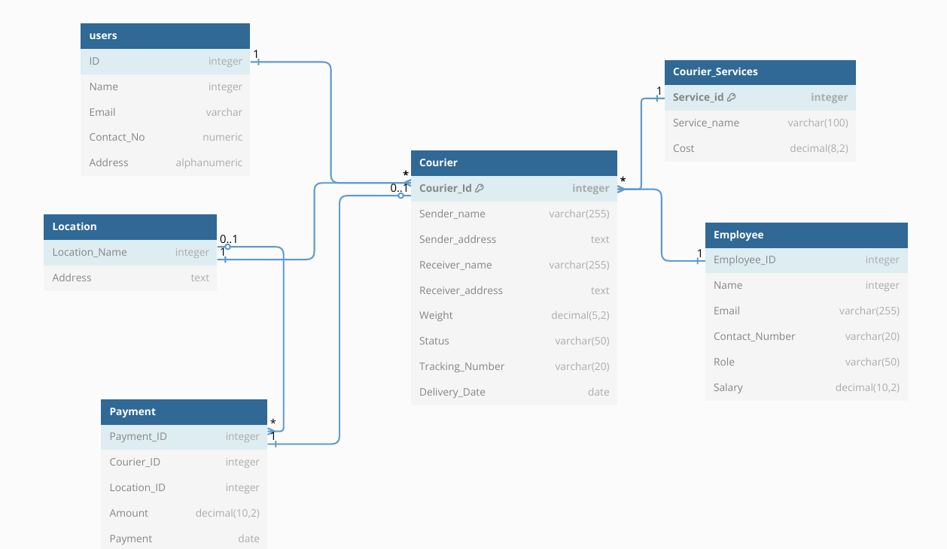

**DEFINING RELATIONSHIP BETWEEN THE ENTITIES:**

* Since, One user can have many couriers, it is defined as one to many relation.
* Many couriers can belong to 1 courier service and therefore it is in the many to one relation.
* An Employee can have many couriers but any courier belongs to one employee, so it is in the many to one relation.
* One courier can have only one payment option and therefore it is defined in the one to one relation.
* Many couriers can belong to same location and so it is many to one relation.
* One location can have many payment options corresponding to the courier and therefore it comes under one to many relation.

**CREATION OF TABLES IN MS SQL SERVER**

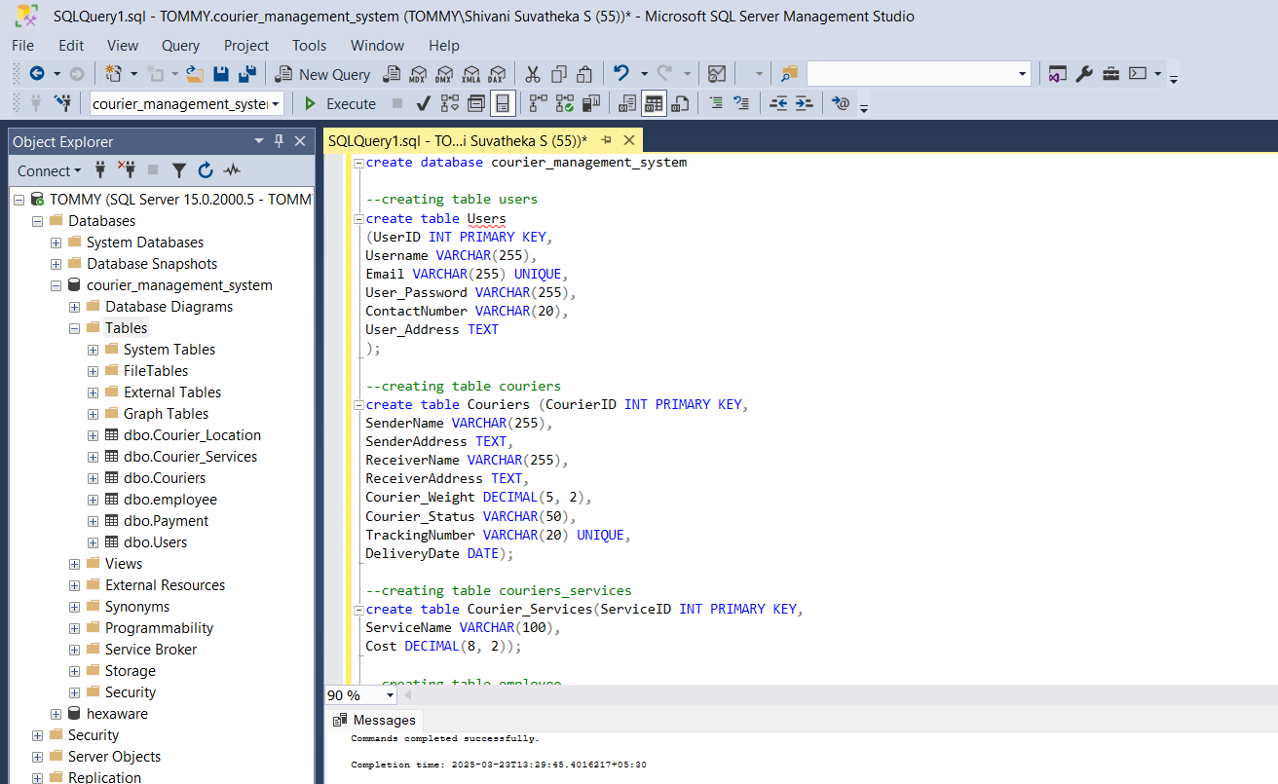

**INSERTING SAMPLE DATA**

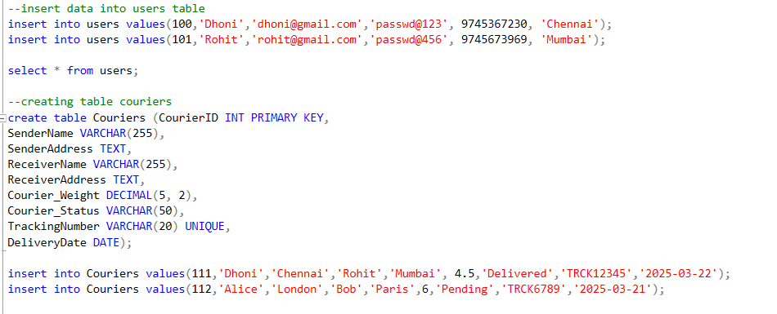

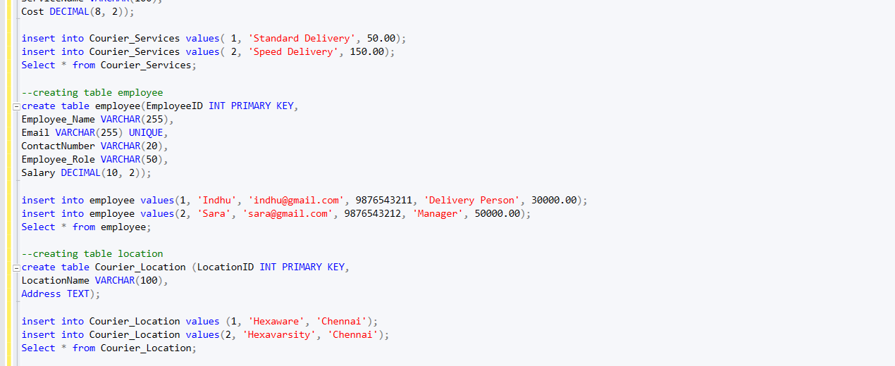

**RESULTS**

